STAGE-1 The Detoxification Stage

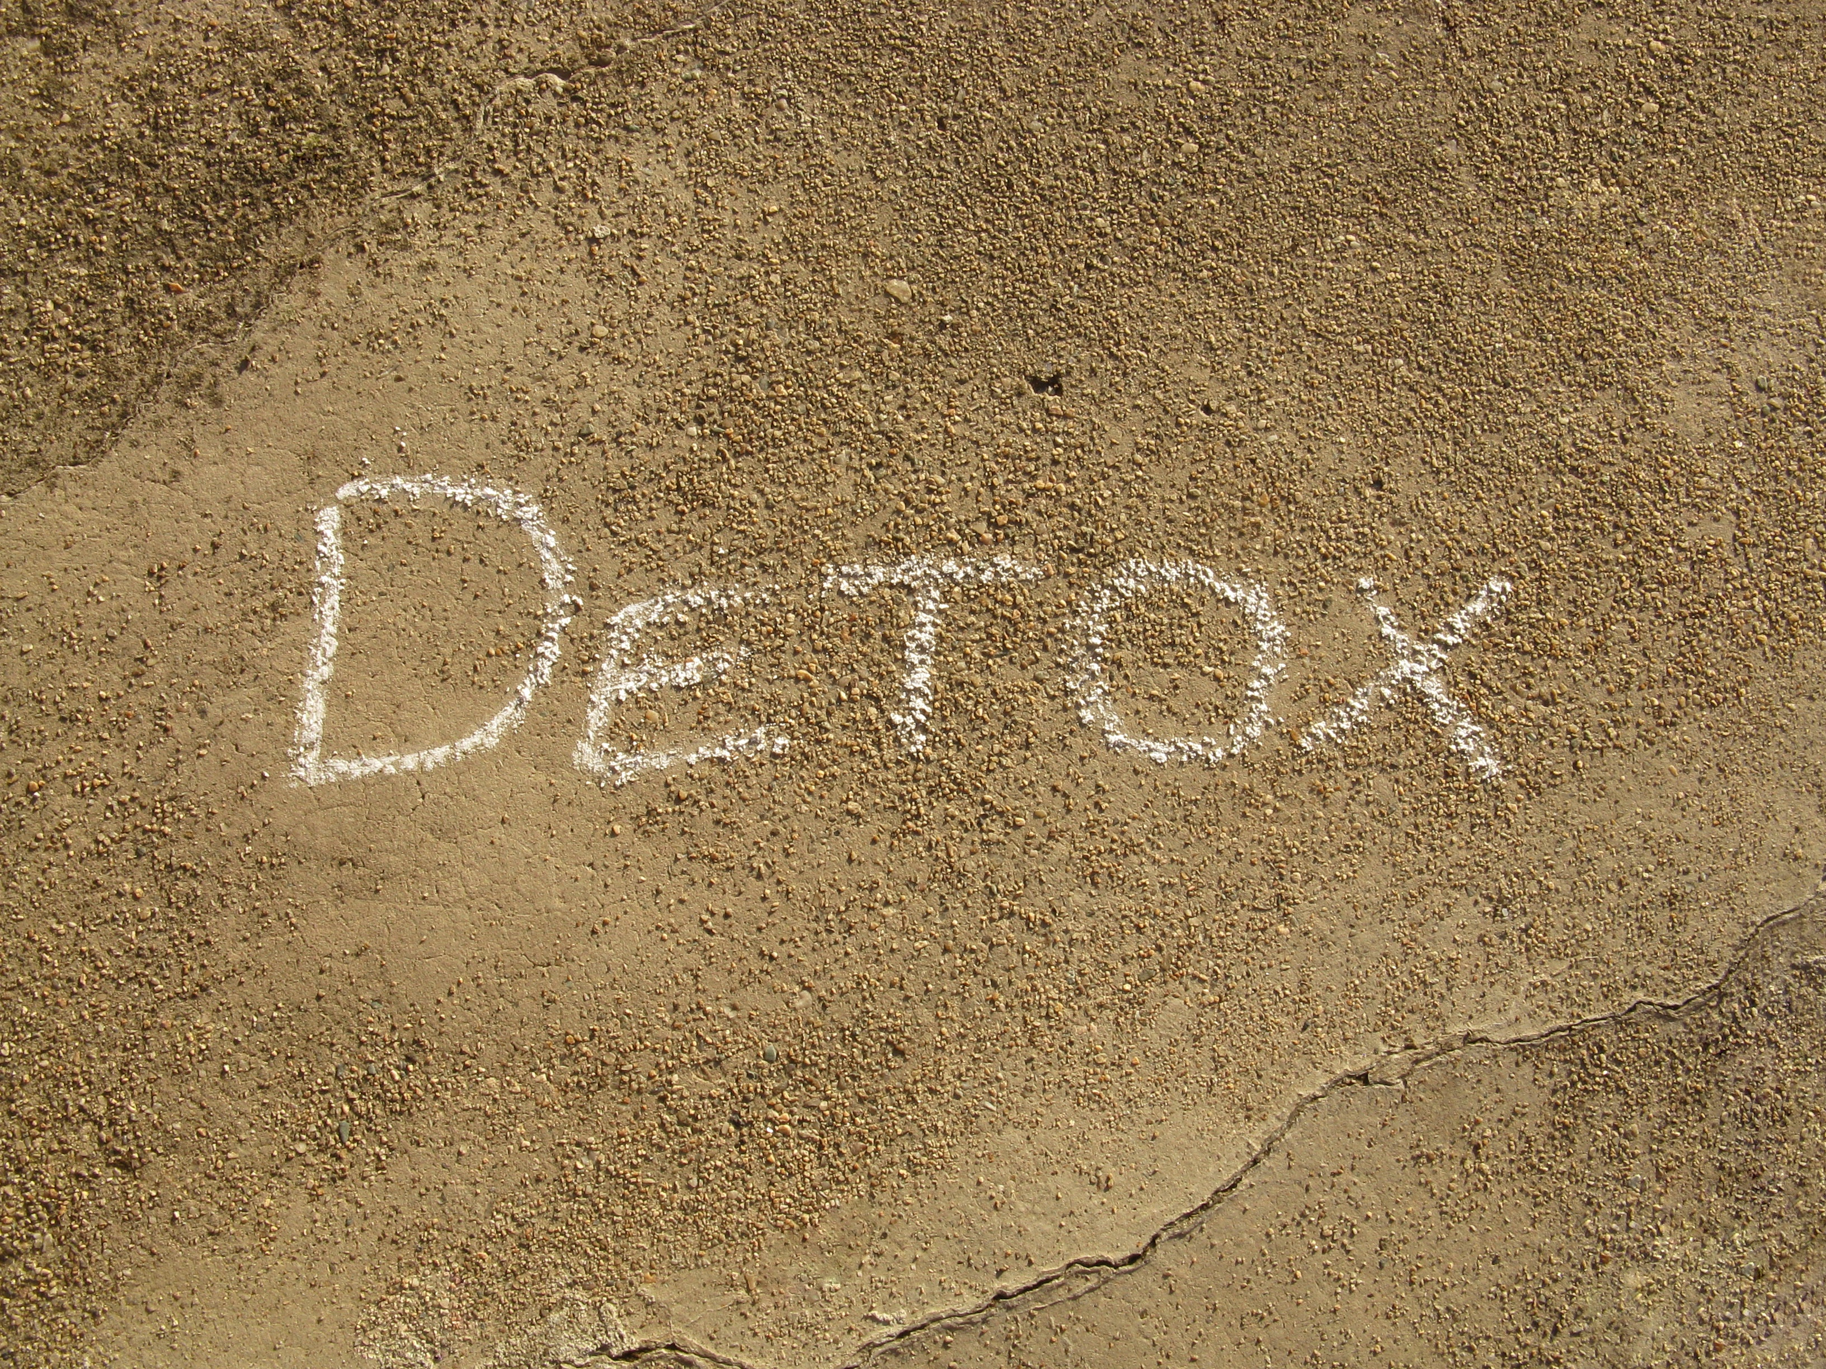

By just looking at the STAGE-1 notes it doesn’t really look so harsh. Yes, your morning toast and cup of tea may have been replaced by a detox tea or a warm lemon water, and yes, you will have to put more effort into preparing your meals for the day, but rest assured these foods have been handpicked and the recipes have been studied to ensure that you will be ridding the body of toxins quite quickly. Included within the daily recipes are diuretic foods, which will flush the body of unwanted water, and along with those, toxins.

Included are also Antioxidant foods, which you will NEED as we are going to be putting quite a strain on your immune system depending on what exercise regime you will use, so please ensure you follow this as much as you can to get maximum results.

You should see a considerable weight loss in the first week on STAGE-1 due to recommendations I have made, so please don't take the plan as something you may try but secretly eat a couple of things you “normally” have, like the odd piece of toast or some cereal. You will then be following YOUR plan and not mine and therefore the results will differ. Our outcome for the first week is to create a hormonal balance but first we have to understand that our bodies are imbalanced, some people take longer to create a long lasting hormonal balance of any sort so please be patient.

As I have mentioned in the full description of the notes you may be quite emotional in the first week, you may just ride the storm and deal with it well but if you are experiencing any unpleasant side effects then let me know ASAP so we can rectify this.

